**Concise and informative title, avoid abbreviations and formulae where possible (Arial, Bold, Center, 14pt)**

**First Author1,2,*, Second Author1 and Third Author2 (Arial, Bold, Center, 10pt)**

1 *Author’s affiliation adress, Full postal adress, postal code, City, Country. (Arial, Italic, 9pt).*2 *Author’s affiliation adress, Full postal adress, postal code, City, Country.*

\**Corresponding author:* [*email@usthb.dz*](mailto:email@usthb.dz)

|  |
| --- |
| **Abstract:** A concise and factual abstract is required. (An approximate maximum of 250 words should be observed.) The abstract should state briefly the purpose of the research, the principal results and major conclusions. An abstract is often presented separately from the article, so it must be able to stand alone. For this reason, References and non-standard or uncommon abbreviations should be avoided. (Arial, 11pt).  **Keywords:** Keyword1, Keyword2, Keyword3, Keyword4.  Provide a maximum of 6 keywords, avoiding general and plural terms and multiple concepts. |

|  |
| --- |
| **Graphical Abstract: (OPTIONAL)**  Authors are encouraged to provide a graphical abstract as a self-explanatory image to appear alongside with the text abstract. Figures should be a high quality image in any common image format. |

1. **INTRODUCTION**

(Arial, 11pt) State the objectives of the work and provide an adequate background, avoiding a detailed literature survey or a summary of the results. Only information essential to the arguments should be presented. All papers should be written in English. e.g., Water scarcity is a pressing global challenge, exacerbated by factors like population growth, climate change, and inefficient water management practices. Desalination, the process of removing salt and other impurities from seawater or brackish water, has emerged as a promising solution to augment freshwater supplies. Among various desalination techniques, membrane-based desalination has gained significant attention for its efficiency, cost-effectiveness, and environmental sustainability. In this article, we delve into the principles, advancements, and applications of membrane-based desalination, shedding light on its pivotal role in addressing water scarcity challenges worldwide. Water scarcity is a pressing global challenge, exacerbated by factors like population growth, climate change, and inefficient water management practices. Desalination, the process of removing salt and other impurities from seawater or brackish water, has emerged as a promising solution to augment freshwater supplies.

1. **MATERIALS & METHODS**

This section should contain brief details about the materials studied, instruments used, specialized chemicals source and related experimental details which allows the work to be reproduced. Divide your article into clearly defined and numbered sections. Subsections should be numbered 1.1 (then 1.1.1, 1.1.2, ...), 1.2, etc (the abstract is not included in section numbering).

**2.1. Subsection:**

Text of first subsection here, text of first subsection here, text of first subsection here, text of first subsection here, text of first subsection here, text of first subsection here, text of first subsection here, text of first subsection here, text of first subsection here, text of first subsection here, text of first subsection here, text of first subsection here.

**2.1.1. Sub-subsection:**

Text of second subsection here, text of second subsection here, text of second subsection here, text of second subsection here, text of second subsection here, text of second subsection here.

**2.2. Subsection:**

Text of first subsection here, text of first subsection here, text of first subsection here, text of first subsection here, text of first subsection here, text of first subsection here, text of first subsection here, text of first subsection here, text of first subsection here, text of first subsection here, text of first subsection here, text of first subsection here.

1. **RESULTS & DISCUSSION**

This should explore the significance of the results of the work. A combined Results and Discussion section is often appropriate. Tables and figures should be designed to maximize the comprehension of the experimental data. The interpreted results should be explained clearly in discussions and should relate them to the existing knowledge in the field as clearly as possible.

**3.1. Subsection:**

Text of first subsection here, text of first subsection here, text of first subsection here, text of first subsection here, text of first subsection here, text of first subsection here, text of first subsection here, text of first subsection here, text of first subsection here, text of first subsection here, text of first subsection here, text of first subsection here.

**4.2. Subsection:**

Text of first subsection here, text of first subsection here, text of first subsection here, text of first subsection here, text of first subsection here, text of first subsection here, text of first subsection here, text of first subsection here, text of first subsection here, text of first subsection here, text of first subsection here, text of first subsection here.

**4.2.1. Sub-subsection:**

Text of second subsection here, text of second subsection here, text of second subsection here, text of second subsection here, text of second subsection here, text of second subsection here.

Example for tables:

Table 1: Insert the table title here with (Arial, 10pt)

|  |  |  |  |  |
| --- | --- | --- | --- | --- |
| Sample | Surface (m²/g) | Diameter (nm) | Volume (cm3/g) | Yield (%) |
| Precursor1 | **14.1** | **45** | **0.066** | **85** |
| Precursor2 | **22.9** | **39** | **0.078** | **92** |
| Precursor3 | **10.4** | **49** | **0.053** | **73** |
| Powder1 | **7.3** | **29** | **0.021** | **55** |
| Powder2 | **4.0** | **22** | **0.017** | **42** |

Example for figures:

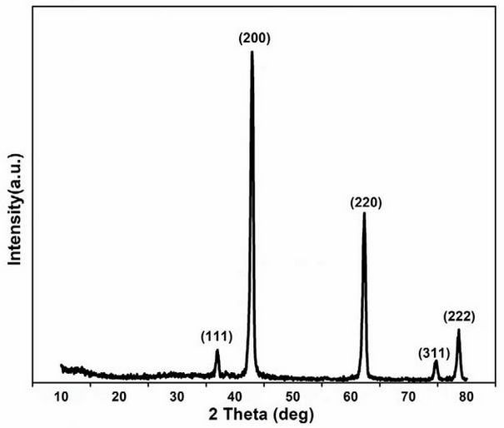

Figure 1: Insert figure title here with (Arial, 10pt)

1. **CONCLUSION**

The main conclusions of the study must be presented in a short alone Conclusion section. (Arial, 11pt) e.g. Membrane-based desalination technology represents a cornerstone in the quest for sustainable water solutions amid growing water scarcity challenges. Through continuous innovation and adoption, membrane desalination has evolved into a reliable, cost-effective, and environmentally friendly approach for producing freshwater from saline water sources. As the global demand for freshwater continues to rise, investments in membrane desalination infrastructure and research are crucial for ensuring water security and resilience in the face of evolving environmental conditions.

1. **REFERENCES**

(Arial, 10pt) e.g.

[1] Elimelech, M., & Phillip, W. A. (2011). The future of seawater desalination: energy, technology, and the environment. Science, 333(6043), 712-717.

[2] Shannon, M. A., Bohn, P. W., Elimelech, M., Georgiadis, J. G., Marinas, B. J., & Mayes, A. M. (2008). Science and technology for water purification in the coming decades. Nature, 452(7185), 301-310.

[3] Cohen-Tanugi, D., & Grossman, J. C. (2012). Nanoporous graphene as a reverse osmosis membrane: Recent insights from theory and simulation. Desalination, 306, 34-38.

[4] Cath, T. Y., Childress, A. E., & Elimelech, M. (2006). Forward osmosis: principles, applications, and recent developments. Journal of membrane science, 281(1-2), 70-87.

[5] Warsinger, D. M., Tow, E. W., & Elimelech, M. (2015). Theoretical framework for membrane desalination processes. Environmental science & technology, 49(17), 10195-10202.

[6] Kim, Y. C., & Elimelech, M. (2009). Direct observation of reverse solute diffusion in osmotically driven membrane processes. Journal of membrane science, 344(1-2), 244-251.

[7] Achilli, A., Cath, T. Y., Marchand, E. A., Childress, A. E., & Fontananova, E. (2010). The forward osmosis membrane bioreactor: a low fouling alternative to MBR processes. Desalination, 253(1-3), 91-97.